We attest that we have worked on each problem in our final deliverables and understand the solutions that we are presenting.

Signed Team 10:

Isaac Rhea (e-signature)

Isaac Rhea

David Jung (e-signature)

David Jung

Ryan Voges (e-signature)

Ryan Voges

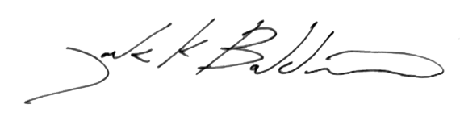

______________________________

Jack Baldwin